Vocabulary
Ch. 53
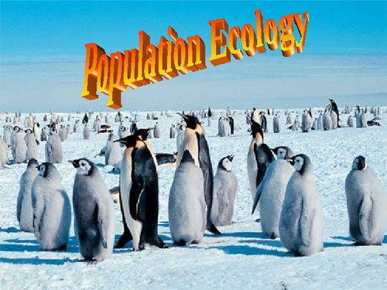

population territoriality exponential population growth
dispersion demography carrying capacity
density k-selection r-selection
immigration age structure density dependent
emigration logistic growth density independent
life history semelparity iteroparity
ecological footprint

