Vocabulary
Ch. 56 - Conservation Ecology

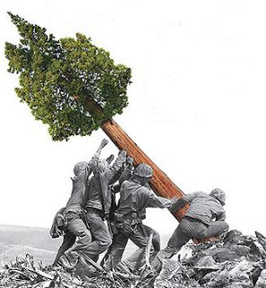

Conservation biology endangered species threatened species
Ecosystem services introduced species extinction vortex
Movement corridor minimum viable population effective population size
Zoned reserve biodiversity hot spot biological magnification
Critical load greenhouse effect assisted migration
Sustainable development

